**Agile Test Plan for Glass Lewis Web Disclosure UI assignment**

Contents

ChangeLog 2

User Story / Epic details: 2

Feature Development Teams and Stakeholder Overview 2

Scope Input 3

Risks/Assumptions/Issues/Dependencies 3

Test Environment 3

Test Approach / Test types 3

## ChangeLog

|  |  |  |  |
| --- | --- | --- | --- |
| **Version** | **Change Date** | **By** | **Description** |
| 1 | 30-03-2021 | Avinash |  |
|  |  |  |  |
|  |  |  |  |

## User Story / Epic details:

Web Disclosure (WD) is a public site where our clients can make the votes public.  
The following acceptance criteria has been provided to the team to create some functionality for a client facing website:  
User has been giving the URL for the WD landing page

1.    Given user is on the landing page for WD site  
And the Country filter is available  
When user selects “Belgium” from the Country filter list on left panel  
And clicks on Update button for the country filter list  
Then the grid displays all meetings that are associated with the country “Belgium”  
And no meetings associated with any other country appear on the list

2.    Given user is on the landing page for WD site  
When user clicks the Company Name “Activision Blizzard Inc” hyperlink  
Then the user lands onto the “Activision Blizzard Inc” vote card page.  
And “Activision Blizzard Inc” should appear in the top banner

As a result, the following set of pages was developed by the team:  
WD Site URL: <https://viewpoint.glasslewis.com/WD/?siteId=DemoClient>

## Feature Development Teams and Stakeholder Overview

|  |  |
| --- | --- |
| **Team/Stakeholder** | **Summary of Involvement** |
| Team A & Team B |  |
| PO / Lead PO |  |

## Scope Input

|  |  |
| --- | --- |
| **Reference Documentation** | **Reference Link** |
| Test Strategy document | Link |
| Main requirement | Link |

## Risks/Assumptions/Issues/Dependencies

List the open risks/assumptions/Issues/Dependencies that have been identified during the preparation of this plan.

* Specify the mitigation plan and the contingency plan for each risk if there one in the table below.
* Ensure your PM/PO are aware of all risks

|  |  |  |  |  |  |  |  |  |
| --- | --- | --- | --- | --- | --- | --- | --- | --- |
| **Date** | **Description** | **Type** | **Jira** | **Owner** | **Importance** | **Contingency plan** | **Comment** | **Status** |
|  |  |  |  |  |  |  |  |  |

## Test Environment

The requirement can be tested on a container, cloud, VM or bare metal.

## Test Approach / Test types

The user stories must go through all the below test types

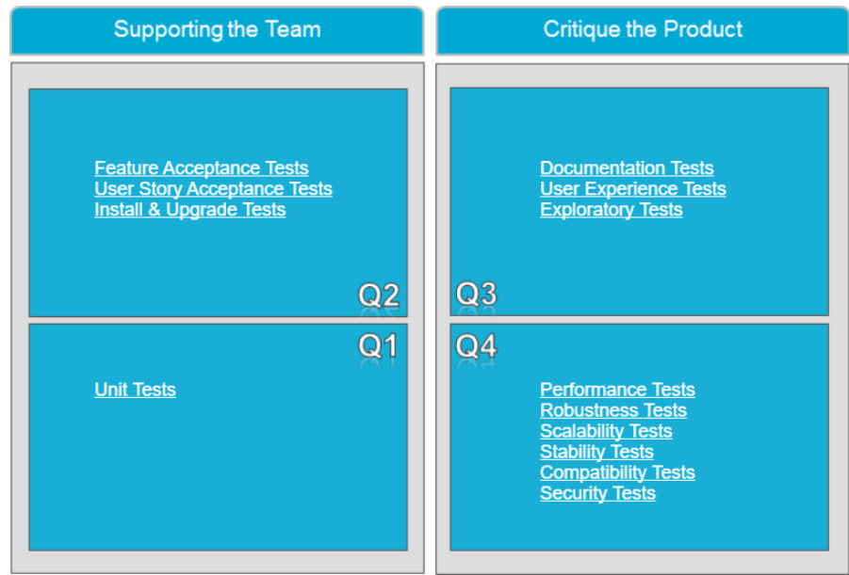

Note: Regression suite must be executed along with above new tests and automate the new tests once the new feature is stable and accepted by stake holders.